Nama: Rifqy Andriansyah

NIM: 2440061991

Dokumentasi Eksternal

1. 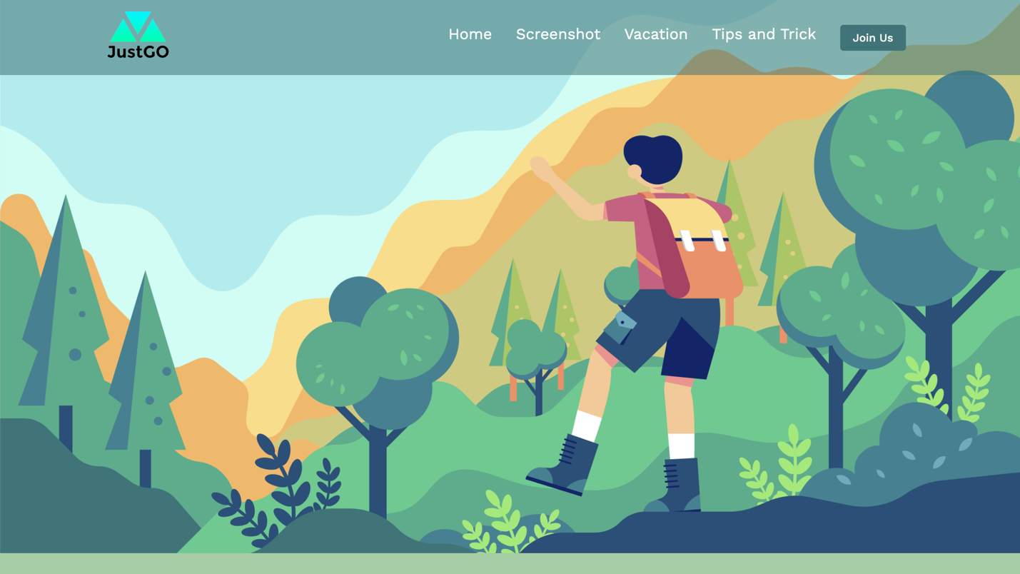Homepage

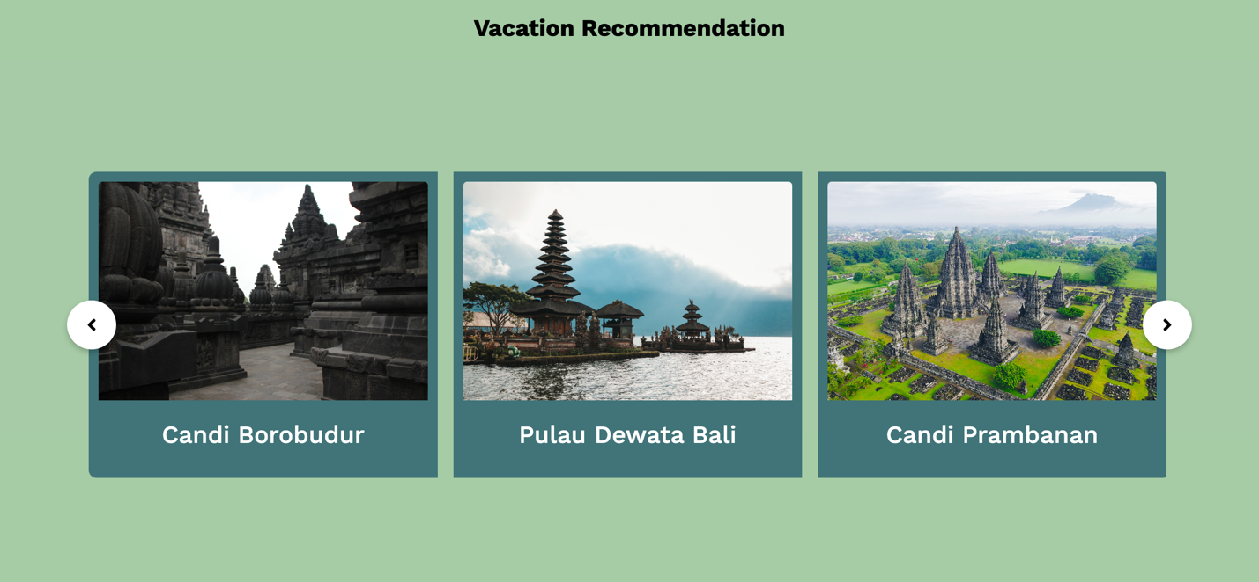

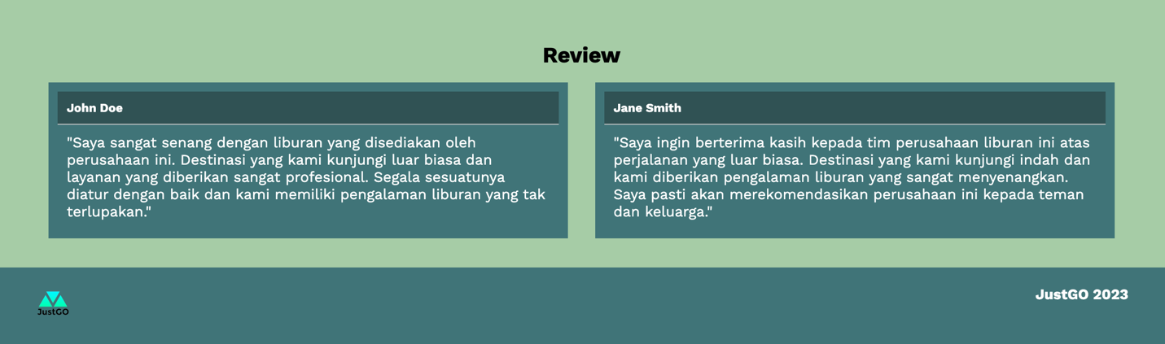

Penjelasan : Pada halaman homepage ini berisi navbar, banner, vacation berupa card image slider, dan dibawah nya juga terdapat bagian container review.

1. 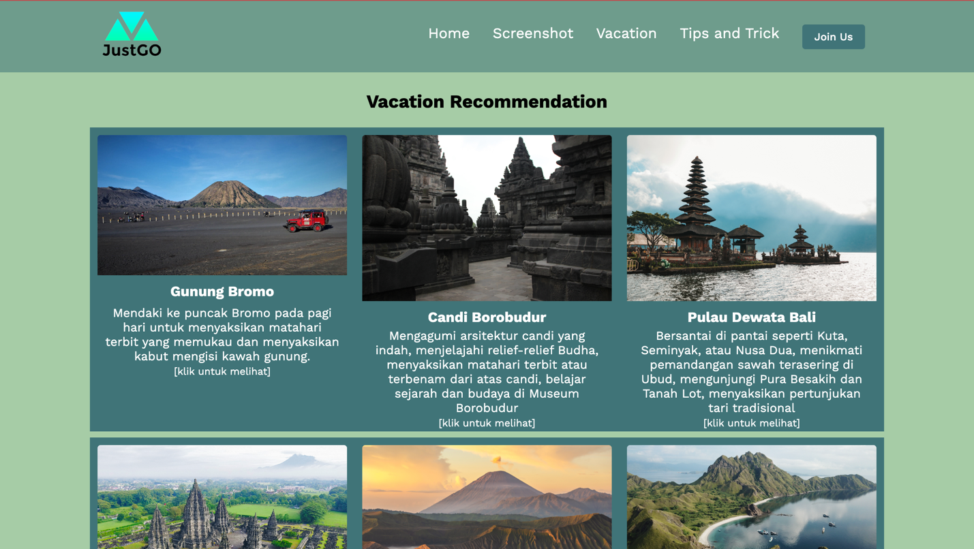Vacation

Penjelasan : Halaman Vacation berisi konten liburan yang jika di-klik akan muncul popup yang berisi penjelasan mengenai liburan tersebut.

1. 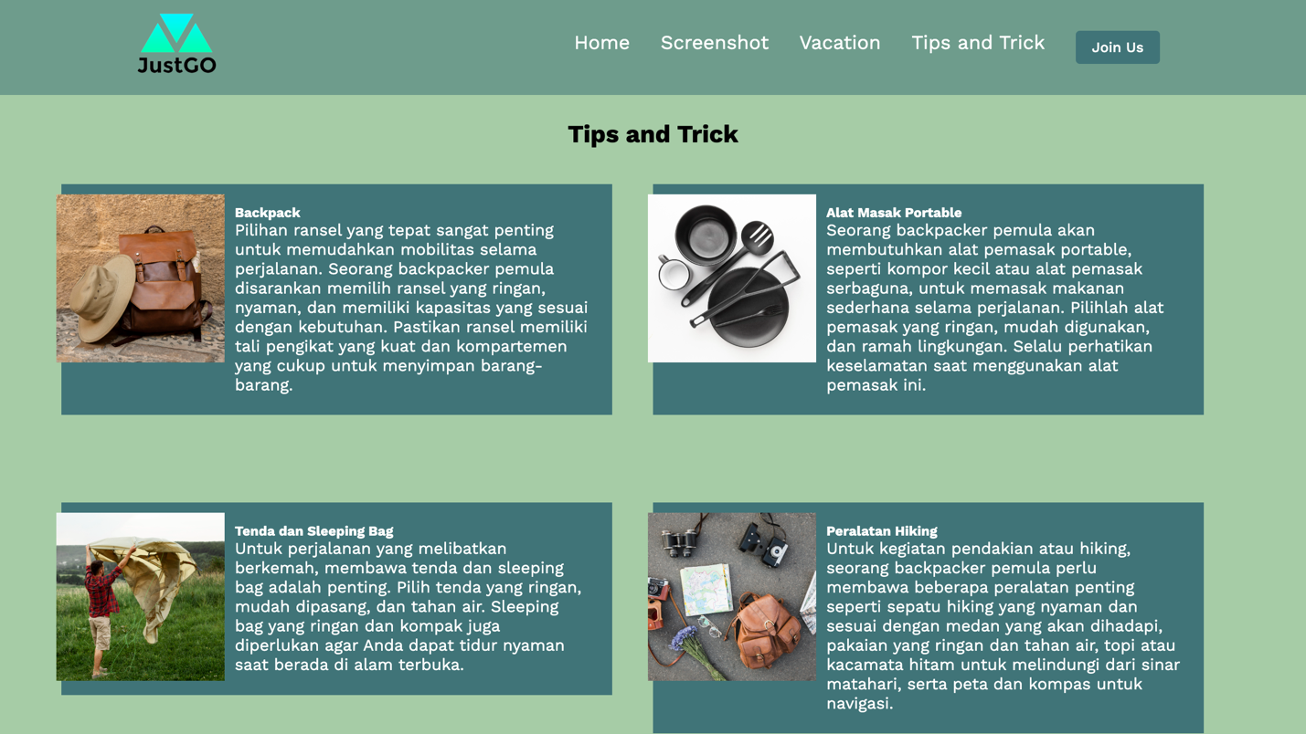Tips and Trick

Penjelasan : Halaman Tips and Trick ini berisi card yang terdapat gambar dan penjelasan mengenai tips untuk backpacker pemula.

1. Screenshoot

Penjelasan : Halaman ini berisi informasi mengenai tempat liburan di berbagai benua dalam bentuk nav-tab.

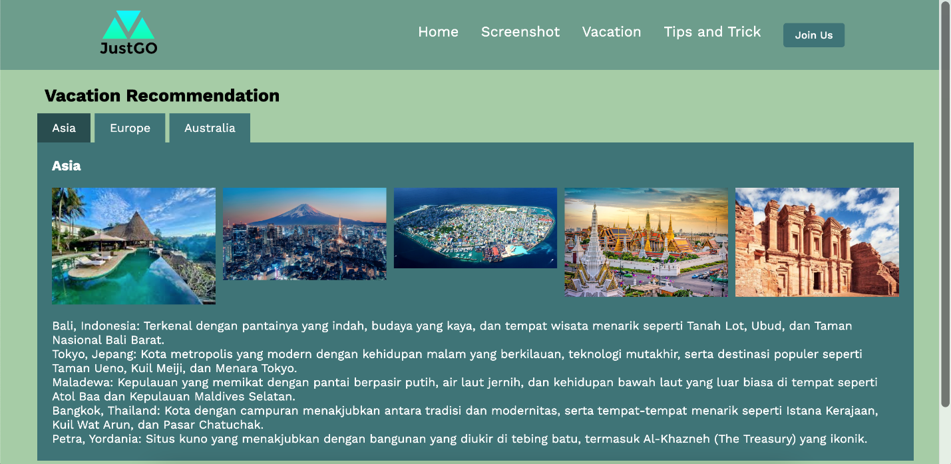

1. Join Us

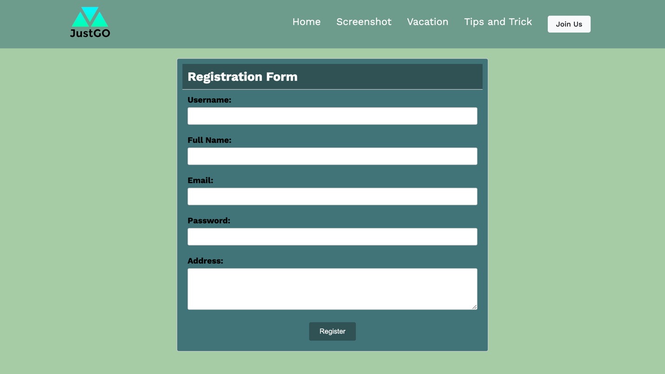

Penjelasan : Pada halaman ini berisi form registrasi yang didalamnya terdapat validasi seperti : form tidak boleh kosong, format email harus sesuai, password harus memiliki minimal 8 character, kemudian username harus memiliki 5 minimal 5 character, dan semua form harus terisi.

Referensi yang digunakan:

<https://dribbble.com/shots/15818436-Ngutan-Travel-Header-Exploration>  
<https://dribbble.com/shots/20509528--Visit-Komura-Travel-Landing-Page>

<https://www.freepik.com/>

<https://www.freepik.com/free-photo/kelingking-beach-sunset-nusa-penida-island-bali-indonesia_11306458.htm>

https://www.freepik.com/free-photo/tropical-beach-landscape-with-deckchair-parasol-from-nosy-be-madagascar-vintage-light-filter_1174386.htm

<https://www.freepik.com/free-photo/cups-pot-near-fire_2419732.htm>

<https://www.freepik.com/free-photo/fish-coral_1115960.htm>

<https://www.freepik.com/free-photo/man-with-hands-wide-open-standing-top-mountain-enjoying-incredible-view-lake_18088638.htm>

<https://www.freepik.com/free-photo/wooden-bridge-leading-adventurous-walk-middle-woods_8857801.htm>

<https://stock.adobe.com/nl/images/Sydney-Ultimate-Skyline/331125755?as_campaign=TinEye&as_content=tineye_match&clickref=1011lwRhpHZW&mv=affiliate&mv2=pz&as_camptype=backlink&as_channel=affiliate&as_source=partnerize&as_campaign=tineye>

<https://www.telegraph.co.uk/travel/destinations/asia/indonesia/bali/articles/surfing-luxury-hotels-bali/>

<https://www.shutterstock.com/image-photo/grand-palace-wat-phra-keaw-sunset-299388287?irclickid=1ZS08s0LoxyPRWhxQeRIaxGNUkFx0A1Qb09OUQ0&irgwc=1&utm_campaign=TinEye&utm_content=108110&utm_medium=Affiliate&utm_source=77643&utm_term>=

<https://www.bigglobaltravel.com/attractions/australias-underwater-hotel/>

<https://www.shutterstock.com/image-photo/male-capital-maldives-28314817?irclickid=1ZS08s0LoxyPRWhxQeRIaxGNUkFx0Fwsb09OUQ0&irgwc=1&utm_campaign=TinEye&utm_content=108110&utm_medium=Affiliate&utm_source=77643&utm_term>=

<https://www.shutterstock.com/image-photo/paris-eiffel-tower-river-seine-sunset-667548661?irclickid=1ZS08s0LoxyPRWhxQeRIaxGNUkFx0F3cb09OUQ0&irgwc=1&utm_campaign=TinEye&utm_content=108110&utm_medium=Affiliate&utm_source=77643&utm_term>=

<https://www.tripadvisor.ca/Attraction_Review-g293986-d9801240-Reviews-Jordan_Horizons_Tours-Amman_Amman_Governorate.html>

<https://www.freepik.com/free-photo/top-view-tableware-collection_12499518.htm>

<https://www.freepik.com/free-photo/front-view-backpack-hat-ground_11127082.htm>

https://www.freepik.com/free-photo/man-preparing-tent-camp_9400867.htm

<https://www.freepik.com/free-photo/traveling-accessories-ground_2483353.htm>

<https://pixabay.com/photos/bromo-whispering-sand-east-java-5011513/>

<https://www.freepik.com/free-photo/travelling-china_1468339.htm>

<https://www.freepik.com/free-photo/pura-ulun-danu-bratan-bali-hindu-temple-surrounded-by-flowers-bratan-lake_8270060.htm>

<https://kumparan.com/jendela-dunia/catat-inilah-waktu-terbaik-ke-pulau-padar-1yVn63mkEgX>

<https://www.freepik.com/free-photo/sunset-mountainous-landscape_5598270.htm>